General Introduction :

The idea of human machine interaction led to research in Speech recognition. Automatic speech recognition uses the process and related technology for converting speech signals into a sequence of words or other linguistic units by means of an algorithm implemented as a computer program. Speech understanding systems presently are capable of understanding speech input for vocabularies of thousands of words in operational environments. Speech signal conveys two important types of information: (a) speech content and (b) The speaker identity. Speech recognizers aim to extract the lexical information from the speech signal independently of the speaker by reducing the inter-speaker variability. Speaker recognition is concerned with extracting the identity of the person. [1]
speech recognition concerns the study of signals of a spoken language where an analysis using the feature extraction method is used to produce a sequence of words. In short, this field attempts to develop machines that mimic human speech communication capabilities. There are several approaches to automatic speech recognition, namely acoustic phonetic, statistical pattern recognition and artificial intelligence approaches.[2]

In speech applications such as dictation software, the application's response to hearing a recognized word may be to write it in a word processor. In an interactive voice response system, the speech application might recognize a person's name and route a caller to that person's phone.Speech recognition is also different from voice recognition, though many people use the terms interchangeably. In a technical sense, voice recognition is strictly about trying to recognize individual voices, not what the speaker said. It is a form of biometrics, the process of identifying a specific individual, often used for security applications.
Because we all have distinct speaking styles — this is why you can tell your mom's voice from your favorite radio talk show host's — computers can take a sample of speech and analyze it for distinct characteristics, creating a "voice print" that is unique to an individual in the same way a fingerprint is. A common voice recognition system might make the user speak a password. It would then compare the speaker's voice print to a stored voice print and authenticate the user if they matched.
Though speech recognition uses some of the same fundamental technology as voice recognition, it is different because it does not try to identify individuals. Rather it tries to recognize what individuals say. It's the difference between knowing who is speaking and what is said. We are currently more concerned about what is said than who is.
Objectives:
1. To recognize 4 different words through automatic speech recognition and convert to 3 digit binary word.
2. Based on the 3 digit binary word, A Image Recognition system to be developed to recognize the object pertaining to the command given.
Literary Survey :
Peeling and Moore (1987) [3] applied MLPs to digit recognition with excellent results. They used a static input buffer of 60 frames (1.2 seconds) of spectral coefficients, long enough for the longest spoken word; briefer words were padded with zeros and positioned randomly in the 60-frame buffer. Evaluating a variety of MLP topologies, they obtained the best performance
with a single hidden layer with 50 units. This network achieved accuracy near
that of an advanced HMM system: error rates were 0.25% versus 0.2% in speaker-dependent experiments, or 1.9% versus 0.6% for multi-speaker experiments, using a 40-speaker database of digits from RSRE. In addition, the MLP was typically five times faster than theHMM system.

Kammerer and Kupper (1988) [4] applied a variety of networks to the TI 20-word database, finding that a single-layer perceptron outperformed both multi-layer perceptrons and a DTW template-based recognizer in many cases. They used a static input buffer of 16 frames, into which each word was linearly normalized, with 16 2-bit coefficients per frame; performance
improved slightly when the training data was augmented by temporally distorted tokens. Error rates for the SLP versus DTW were 0.4% versus 0.7% in speaker-dependent experiments, or 2.7% versus 2.5% for speaker-independent experiments.

Lippmann (1989) [5] points out that while the above results seem impressive, they are mitigated by evidence that these small-vocabulary tasks are not really very difficult. Burton et al (1985) demonstrated that a simple recognizer based on whole-word vector quantization, without time alignment, can achieve speaker-dependent error rates as low as 0.8% for the TI
20-word database, or 0.3 for digits. Thus it is not surprising that simple networks can achieve good results on these tasks, in which temporal information is not very important.

Burr (1988) [6] applied MLPs to the more difficult task of alphabet recognition. He used a static input buffer of 20 frames, into which each spoken letter was linearly normalized, with 8 spectral coefficients per frame. Training on three sets of the 26 spoken letters and testing on a fourth set, an MLP achieved an error rate of 15% in speaker-dependent experiments, matching the accuracy of a DTW template-based approach.
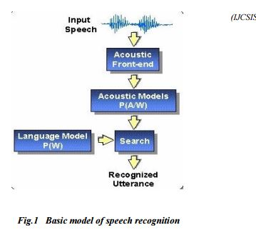

Procedure :

Speech recognition systems can be separated in several different classes by describing what types of utterances they have the ability to recognize. These classes are classified as the following: Isolated Words, Connected Words, Continuous Speech, Spontaneous Speech. In this project we work on Isolated words since our objective here is to recognize only 4 words that are isolated from each other.

Isolated Words: Isolated word recognizers usually require each utterance to have quiet (lack of an audio signal) on both sides of the sample window. It accepts single words or single utterance at a time. These systems have "Listen/Not-Listen" states, where they require the speaker to wait between utterances (usually doing processing during the pauses). Isolated Utterance might be a better name for this class.

Approaches to speech recognition: Basically there exist three approaches to speech recognition. They are
a)Acoustic Phonetic Approach
b)Pattern Recognition Approach
c)Artificial Intelligence Approach.
The pattern-matching approach [8] involves two essential steps namely, pattern training and pattern comparison. We use Neural Networks as a tool here to perform both the steps.
Recognizers generally use a similar process to figure out what a speaker said:
1.The Automatic Speaker Recognition(ASR) loads a list of words to be recognized. This list of words is called a grammar.
2.The ASR loads audio from the speaker. This audio is represented as a waveform, essentially the mathematical representation of sound.
3.The ASR compares the waveform to its own acoustic models. These are databases that contain information about the waveforms of individual sounds and are what allow the engine to recognize speech.
4.The ASR compares the words in the grammar to the results it obtained from searching its acoustic models.
5.It then determines which words in the grammar the audio most closely matches and returns a result.
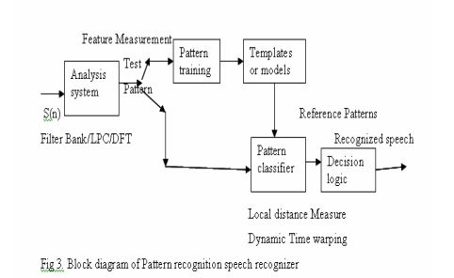

In the pattern-comparison stage of the approach, a direct comparison is made between the unknown speeches (the speech to be recognized) with each possible pattern learned in the training stage in order to determine the identity of the unknown according to the goodness of match of the patterns. The pattern-matching approach has become the predominant method for speech recognition in the last six decades. A block schematic diagram of pattern recognition is presented in fig.2. In this, there exists two methods namely template approach and stochastic approach.
Template based approach [9] to speech recognition have provided a family of techniques that have advanced the field considerably during the last six decades. The underlying idea is simple. A collection of prototypical speech patterns are stored as reference patterns representing the dictionary of candidate s words. Recognition is then carried out by matching an unknown spoken utterance with each of these reference templates and selecting the category of the best matching pattern. Usually templates for entire words are constructed. This has the advantage that, errors due to segmentation or classification of smaller acoustically more variable units such as phonemes can be avoided. Neural Networks are used as a tool for template approach. The other approach is Stochastic Approach where we use Hidden Markov Model.
Existing techniques for speech recognition have been represented diagrammatically in the following figure 3.

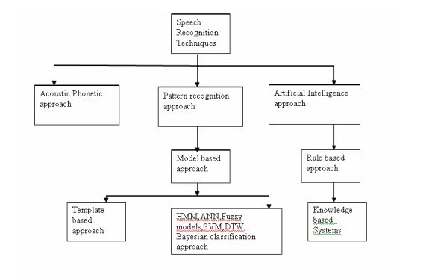
Feature Extraction :

In speech recognition, the main goal of the feature extraction step is to compute a parsimonious sequence of feature vectors providing a compact representation of the given input signal. The feature extraction is usually performed in three stages. The first stage is called the speech analysis or the acoustic front end. It performs some kind of spectro temporal analysis of the signal and generates raw features describing the envelope of the power spectrum of short speech intervals. The second stage compiles an extended feature vector composed of static and dynamic features. Finally, the last stage( which is not always present) transforms these extended feature vectors into more compact and robust vectors that are then supplied to the recognizer. Although there is no real consensus as to what the optimal feature sets should look like, one usually would like them to have the following properties: they should allow an automatic system to discriminate between different through similar sounding speech sounds, they should allow for the automatic creation of acoustic models for these sounds without the need for an excessive amount of training data, and they should exhibit statistics which are largely invariant across speakers and speaking environment. There are many feature extraction methods in speech recognition. The following table lists some of them.
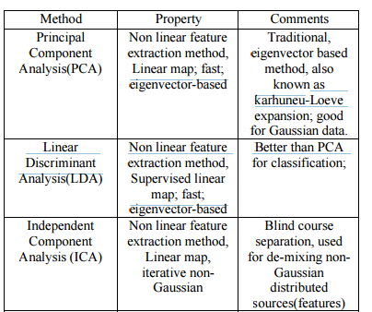

From the list of Feature extraction methods we use LDA method as it has more advantages over others and is suitable for our application. Which is then applied to Multilayer Perceptron(MLP) neural network for classification.

Future Scope :

There are copious future applications for speech recognition. The output evaluated after speech recognition are used in various programs and applications to make physical interaction less systems. One such future application is our second objective where we use the O/P we got in first objective to be given to image recognition system where it recognizes the object placed in front of it based on the command given.

References :

1. Suma Swamy and K.V Ramakrishnan,AN EFFICIENT SPEECH RECOGNITION SYSTEM ,An International Journal (CSEIJ), Vol. 3, No. 4, August 2013
2. Bassam A.Q.Al-Qatab and Raja.N.Aninon, “Arabic Speech Recognition using Hidden Markov Model ToolKit (HTK)”, IEEE Information Technology (ITSim), 2010,page 557-562.
3. S.M. Peeling, R.K. Moore, Isolated digit recognition experiments using the multi-layer perceptron.1987
4. Bernhard R. Kämmerer, Wolfgang A. Küpper Experiments for isolated-word recognition with single- and two-layer perceptrons 1988
5.Richard P Lippmann, Review of Neural Networks for Speech Recognition, 1989
6.Burr, D.J., "Experiments on neural net recognition of spoken and written text," in Acoustics, Speech and Signal Processing, IEEE Transactions on , vol.36, no.7, pp.1162-1168, Jul 1988.
7. M.A.Anusuya ,S.K.Katti , "Speech recognition by machine: A review," in Proceedings of the IEEE , vol.64, no.4, pp.501-531, April 2009.
8.Rabiner & Juang - Fundamentals of Speech Recognition 1993
9.R.K.Moore, Twenty things we still don t know about speech , Proc.CRIM/ FORWISS Workshop on Progress and Prospects of speech Research an Technology , 1994.

